
In partnership with New City College
Invite you to St John’s College Open Day
Thursday, 22nd October 2026
Two Sessions to choose from
11.00am or 2.00pm

St John’s College is part of the specialist provision of New City College for learners with a wide range of needs including moderate to severe Learning Difficulties, autistic spectrum disorder (ASD) and those with associated speech, language and communication difficulties, aged 19-25 years.
This is your chance to visit and explore our fantastic College. See what we can offer to prospective students, as well as an opportunity to meet our current students and staff.

St John’s College
Turpins Lane, Woodford Bridge, Essex IG8 8AX
Telephone - 0208 504 1818 Option 2 – Please book
andriannanicolaou@stjohnsrcschool.co.uk
The aim of St John’s College is to enable its learners to gain the knowledge, skills and confidence they need to make a
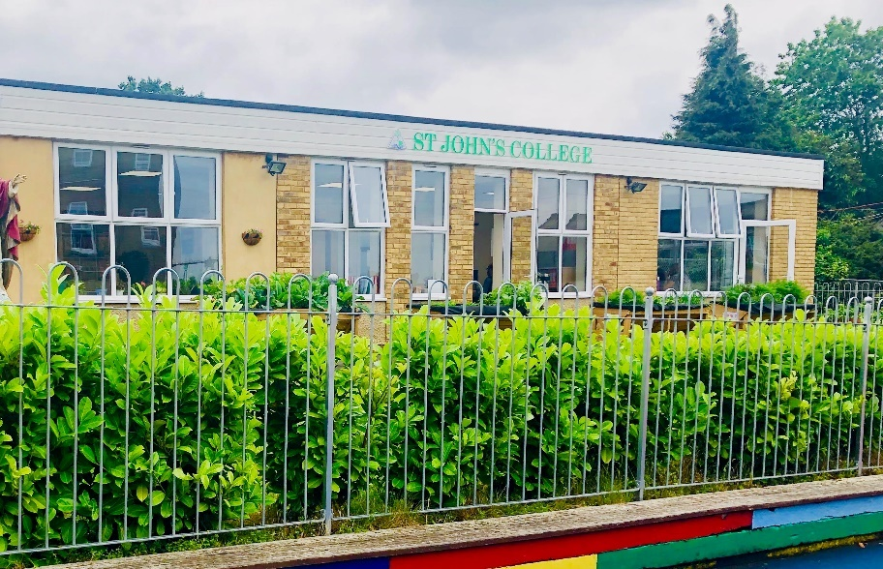
successful transition to Adulthood and to live, work and contribute as fully as possible as part of their Community.

Employment / Education

Independent Living, Travel Training, Cooking,

Good Health and Wellbeing

Friends, Relationships,

and Community Inclusion

